**Phrase Illustrations**

By Ben Perrine

1. Everything except the cat was there.

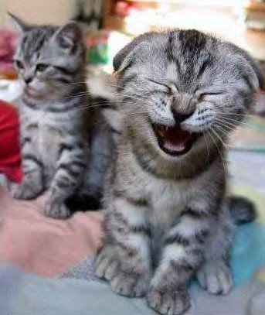

1. There was a huge dog in the attic!

[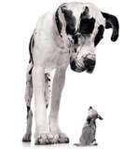](http://search.live.com/images/results.aspx?q=big+dog&form=QBIR#focal=a5f3fb63c2bc7eba76e6ad8ce939f3da&furl=http://www.southwicklowcanineclub.com/images/open_show_images/big_dog_little_dog.jpg)